STUDENT JOURNAL
FIJI & DEBRIEF

Name: ______________ _____

Contents
Introduction 3
Packing List (Example for Fiji) 4
Fijian Language 5
SERVANTS Pre-Departure Devotions 9
Spiritual Dependency 10
Eyes for Others 10
Renew Your Mind 11
Viewpoint 11
Above Disgrace 12
Nurture Knowledge 12
Team Unity 13
Stretch 13
JOURNAL: Day One 14
Day Two 16
Day Three 18
Day Four 20
Day Five 22
Day Six 24
Day Seven 26
Day Eight 28
Day Nine 30
Day Ten 32
Lectio Divina Shared in a small group 34
Five Symbols 35
Debrief Notes 36
Fiji Debrief Notes 37
DEBRIEF: Preparing for Re-entry 38
Debrief Session 1: HERE 39
Debrief Session 2: HERE to THERE 42
Sharing my story 43
Debrief Session 3: THERE 44
Keeping the Flame Alive 46
BACK HOME: Re-vision for Mission 47
God’s walk with me since the GO Team 47
God’s Call: How is God inviting me to grow? 50
God’s Community: Keeping us accountable and growing in God’s mission 55
God’s Mission: How can we engage with God’s broken world 59

Introduction
Daily Journaling is a requirement for the time in Fiji! We want you to get the most out of your experiences and having somewhere to write notes and reflect will help you do that well. This book is designed to be used alongside your ‘On Mission’ devotional book. In here you will find space for daily ‘snapshot’ on what you have seen, as well as some blank space for writing down your thoughts, prayers and experiences.

About Journaling:
Ever noticed how the word journal and journey are so similar – perhaps we can think of journal as taking note of our journey; ask yourself what did you notice today? What do you want to pause over as you think about the day? What makes you wild with excitement? What makes you crazy with frustration? What did you learn today about yourself? About God? Even if it seems insignificant take the time to note it down.
We also use journals as a record of our journey so that we can look back and see how far we’ve come and remember what we have been doing. Sometimes to note things we wish to remember in our prayers. Sometimes we write to note down a new understanding we have had as a result of seeing something on our journey. Sometimes to draw pictures of things we have seen when there really are no words. Sometimes it’s just a way to help with our thinking and processing about what is happening.
We hope you find journal helpful and encouraging as a part of going deeper with God through your time in Fiji.

Packing List (Example for Fiji)

Clothing/Shoes  - 1 pair of closed in shoes /trainers  - Comfortable sandals/flip flops  - Socks  - Underwear!  - T-shirts  - 1 warmer top the evening  - Lightweight rain coat  - Swimming togs (modest girls)  - Sun hat,  - Sun block  Personal  - Toothpaste, Toothbrush  - Comb/brush/hair ties  - Deodorant  - Soap or body wash  - Shampoo/Conditioner  - Body lotion  - Towel  Sleeping gear  - Light weight sleeping bag  - Modest sleeping wear  - Sleeping bag liner or sewn up sheet (optional)  - Pillow case (optional)  - Ear plugs and eye mask (optional)  Guys  - 1x formal trousers and 2x formal shirt  - Shorts/trousers/jeans  - Sulu (if you have one)  Optional electronic equipment*  - Camera (if you want to, optional) | Girls  - Skirts or dresses (or a wrap) that are knee length or longer  - Modest tops - No low cut ones or strapless or shoestring  - 1 blouses or more formal top  - 1 pair of ¾ pants or trousers  - Bike pants or lightweight leggings to go under lava lavas  - Light scarf or shawl (optional)  - Sanitary items  First Aid/ Medication  - Your own personal medication  - Insect repellent with Deet  - Diarrhoea and constipation tablets if prescribed  All important documentation  - Passport  - Vaccination booklet  - Photocopy of passport to put in check in bag  Other  - Wet wipes, hand sanitizer (optional)  - Tissues (optional)  - Extra plastic bags/ zip lock bags (optional)  - Water bottle or one which has a filter attached (optional)  - Bible  - Other diary or journal and pen  - Some photos of family, friends to show people (optional)  - Any ministry preparation materials you need to bring

Fijian Language

Basics
English | Fijian
Good day (a polite greeting and one of the first Fijian phrases you will hear) | Nibula - (nimbula)
A less formal greeting (literally ‘health’ and ‘life’) | Bula - (mbula)
Good morning | Ni sa yadra - (ni sah yandra)
Goodbye/Good night (literally, ‘sleep’). | Ni sa moce - (ni sah mothay)
Come here | Lako mai eke - (lahko my kay)
Good/Thank you | Vinaka - (vinahka)
Thank you very much | Vinaka vaka levu - (vinahka vaka layvu)
Where do you come from? | O ni lako mai vei? (o ni lahko my vay)
I come from New Zealand | Au lako mai Niu Siladi (ow lahko my new silandi)

Popular phrases and Fijian expressions
Below are a few popular Fijian words used in everyday conversations.
English | Fijian
Good morning | vinaka vaka levu
I am hungry | Au sa via kana
I am thirsty | Au sa via gunu
I am sleepy | Au sa via moce
Good Night | Sa moce
Come here | Lako mai
I am going to Taveuni | Au lako ni Taveuni
I am from New Zealand | Au sa lako mai New Zealand
No worries | Sega na lega

Some useful words
English | Fijian
Yes | io - (ee-oh)
No | sega - (sayngah)
Work | cakacaka - (thaka-thaka)
Bad | ca - (tha)
Big | many - levu - (layvu)
Bird | manumanu vuka - (mahnumahnu vukah)
Boy | male - tagane - (tahng-ahnay)
Child | gone - (ngonay)
Comb | i-seru - (ee-seru)
Cup | bilo - (bee-low)
Eat | kana - (kahna)
Fish | ika - (ee-kah)
Food | kakana - (kakahna)
Girl | female - yalewa - (yah-lay-wah)
Handsome, beautiful | totoka - (toe-toe-kah)
Happy, satisfied | marau - (mah-rau)
House | vale - (va-lay)
Man | tagane - (tahng-ahnay)
Man | turaga - (tu-rahng-ah)
Money | ilavo - (ee-lah-vo)
Pot | kuro - (koo-row)
Sleeping house | bure - (bur-ay)
Small | lailai - (lie-lie)
Smart | matai - (mah-tye)
Stone | vatu - (vah-too)
Stupid or crazy | lialia - (lee-ah lee-ah)
Taro | dalo - (dahlo)
Today | nikua - (nickuah)
Toilet | vale lailai - (vah-lay lie-lie)
Tomorrow | ni mataka - (ni mahtahka)
Tree | vu ni kau - (vu ni cow)
Village | koro - (koro)
Woman | marama - (mah-rah-mah)
Yesterday | nanoa - (na-noa)

Some useful concepts
English | Fijian
Killing time, fooling around | moku siga - (moku singah)
Wandering around | gade - (gan-day)
Go slowly, take your time | vaka malua - (vaka-mahluah)
Eat heartily | kana vaka levu - (kahna vaka layvu)
Taboo, forbidden | tabu - (tamboo)
Exclamation of regret | isa, isa lei - (ee-sah, ee-sah lay)
Ashamed, shy | madua - (man-doo-ah)
Go ahead and try | tovolea mada - (toe-vo-lay-ah mahndah)
A request | kerekere - (kerri-kerri)

Greetings and civilities
Only rarely will the visitor encounter a Fijian Indian who does not speak English. Just the same, Indians will appreciate the visitor who extends him or herself by learning a few commonly used expressions.
Many greetings are used but the most heard is ‘Namaste’, meaning both hello and goodbye. Another common greeting, corresponding to the English ‘How are you?’ is ‘Kaise?’ The answers might be:
English | Fijian
I’m fine | Thik hai - (teak high)
Right/OK | Rait - (right)
Well/Good | Accha - (ach-cha)

Some useful phrases
English | Fijian
What’s your name? (Formal) | Ap ke nam ka hai? - (app kay nam key-yah high)
What’s your name? (Familiar) | Tumar nam ka hai? - (too-mar nam key-ya high)
My name is… | Hamar nam…hai. - (hah mar nahm…high)
I didn’t understand | Ham nhii samjha - (hahm anh-hee sahm-jah)
Please say it again | Fir se bolna - (fear say boll nah)
I don’t know | Pata nahi. - (patah na-hee)
What’s happening? | Ka hue? - (key-yah who-way)
What happened? | Ka bhay? - (key-yah ba-hay)
I’m tired | Ham thak gaya. - (hahm-tahk gah-hay)
I like… | ...accha lange - (...ach-cha la-gay)

When you’re out
English | Fijian
The food is very good | Khana bahut accha hai - (kana bahoot ach-cha high)
Just a little | Thora thora - (tora tora)
Enough! | Bas! - (bahs)
Finished | Khalas - (kalas)
My stomach is full | Pet bhar gaya - (pet bahar gah-yah)

When you’re shopping
English | Fijian
How much is it? | Kitna dam hai? - (kit-nah dahm high)

SERVANTS Pre-Departure Devotions

In the week leading up going to Fiji, use this acronym of SERVANTS for personal devotions to help you in reflection and preparation:
Spiritual Dependency
Eyes for Others
Renew your Mind
Viewpoint
Above Reproach
Nurture Knowledge
Team Unity
Stretch
This acronym SERVANTS follows on from the learner/servant focus that we looked at during our training weekend. Being Learners and Servants is important for our attitude and actions in Fiji. It’s also a model for ministry, summed up in Jesus’ own words recorded in Mark 10:43-45:
“Whoever wants to become great among you must be your servant,
and whoever wants to be first must be slave of all.
For even the Son of Man did not come to be served,
but to serve, and to give his life as a ransom for many.”
We’ll look at the first 4 letters together during the preparation weekend. Then we suggest you make your way through the other 4 in the days before we leave for Fiji on Friday (one a day). As you do so, continue to ask God to show you all He might be asking you to do and be whilst on the Cross Cultural Ministry Exchange.

This devotion material is from iteams NZ Team Leader Training Workshop. 2011 Delta Ministries.

Spiritual Dependency
Developing spiritual dependency on God is key for being a Servant. Spiritual Dependency basically means that we look to God to be our Source of life.

Key Verse: John 15:5:
“I am the Vine, you are the branches. When you’re joined with me and I with you, the relation intimate and organic, the harvest is sure to be abundant. Separated, you can’t produce a thing.”

Questions for reflection:
Can you think of times when you have/haven’t relied on God and how that affected the outcome of a situation?
If Spiritual Dependency is important in helping shape you as a Servant of Jesus, what practical things might help you grow in Spiritual Dependency? How can you put these in place in Fiji?

Prayer

Eyes for Others
Eyes for others means focusing on the needs of others, even when we feel uncomfortable and needy ourselves

Key Verse: Philippians 2:1-4:
“If you’ve gotten anything at all out of following Christ, if his love has made any difference in your life, if being in a community of the Spirit means anything to you, if you have a heart, if you care— then do me a favour: Agree with each other, love each other, be deep-spirited friends. Don’t push your way to the front; don’t sweet-talk your way to the top. Put yourself aside, and help others get ahead. Don’t be obsessed with getting your own advantage. Forget yourselves long enough to lend a helping hand.”

Questions for reflection:
Can you think of times when you have/haven’t had ‘eyes for others’ and how that affected the outcome of a situation?
What might be some of the challenges you might face in having Eyes for Others?
If having Eyes for Others is important in helping shape you as a Servant of Jesus, what practical things might help you grow in having Eyes for Others?? How can you put these in place in Fiji?

Prayer

Renew Your Mind
Renewing your Mind means keeping your minds pure and humble; choosing to ask God to help you focus on him and what he is asking you to do.

Key Verse: Romans 12:1-2:
“Therefore, I urge you, brothers and sisters, in view of God’s mercy, to offer your bodies as a living sacrifice, holy and pleasing to God—this is your true and proper worship. ² Do not conform to the pattern of this world, but be transformed by the renewing of your mind. Then you will be able to test and approve what God’s will is—his good, pleasing and perfect will.”

Questions for reflection:
What are some of the things that might distract you from God and letting God renew your focus?
What might some of the distractions be in Fiji for you?
If Renewing your Mind is important in helping shape you as a Servant of Jesus, what practical things might help you grow in Renewing Your Mind?? How can you put these in place in Fiji?

Prayer

Viewpoint
Viewpoint is about our expectations. We remember that God is interested in the process not just the product – we need to remind ourselves that mission is God’s work

Key Verse: Ephesians 2:10
“Now God has us where he wants us, with all the time in this world and the next to shower grace and kindness upon us in Christ Jesus. Saving is all his idea, and all his work. All we do is trust him enough to let him do it. It’s God’s gift from start to finish! We don’t play the major role. If we did, we’d probably go around bragging that we’d done the whole thing! No, we neither make nor save ourselves. God does both the making and saving. He creates each of us by Christ Jesus to join him in the work he does, the good work he has gotten ready for us to do, work we had better be doing.”

Questions for reflection:
How would you define a successful Cross-Cultural Exchange to Fiji? How do you think Jesus would?
If keeping a God-centred Viewpoint is important in helping shape you as a Servant of Jesus, what practical things might help you grow in having God’s Viewpoint?? How can you keep realistic expectations in Fiji?

Prayer

Above Offence
Above Offence is about making sure we do our best to be respectful and avoid offending others. We do this through our actions, what we wear, what we say, and how we treat others.

Key Verse: 1 Timothy 3:7
“…one must also have a good reputation with those outside the church, so that they will not fall into disgrace and into the devil’s trap.”

Questions for reflection:
When you realise you’ve done something offensive, how do you normally respond? Are you defensive or apologetic? How would you respond in Fiji if you offended someone?
If being Above Offfence is important in helping shape you as a Servant of Jesus, what practical things might help you grow in being Above Offence?? How can you practically choose to respect other team members and our Fijian hosts while in Fiji?

Prayer

Nurture Knowledge
Nurture Knowledge is about becoming students of culture. We don’t judge and remember that another culture isn’t wrong or bad, it’s just different.

Key Verse: 1 Corinthians 9:22
“Even though I am free of the demands and expectations of everyone, I have voluntarily become a servant to any and all in order to reach a wide range of people: religious, nonreligious, meticulous moralists, loose-living immoralists, the defeated, the demoralized—whoever. I didn’t take on their way of life. I kept my bearings in Christ—but I entered their world and tried to experience things from their point of view. I’ve become just about every sort of servant there is in my attempts to lead those I meet into a God-saved life. I did all this because of the Message. I didn’t just want to talk about it; I wanted to be in on it!”

Questions for reflection:
If Nurturing Knowledge is important in helping shape you as a Servant of Jesus, what practical things might help you grow in Nurturing Knowledge?? What ways can you show you’re interested in the culture of Fijians when you are there?
How could not embracing Fiji Culture become a barrier for friendships in Fiji?

Prayer

Team Unity
Team Unity is about being committed to the group, in striving together, love, grace and forgiveness.

Key Verse: Philippians 1:27
“Meanwhile, live in such a way that you are a credit to the Message of Christ. Let nothing in your conduct hang on whether I come or not. Your conduct must be the same whether I show up to see things for myself or hear of it from a distance. Stand united, singular in vision, contending for people’s trust in the Message, the good news, not flinching or dodging in the slightest before the opposition.”

Questions for reflection:
What factors might keep the team from ‘striving together’ in unity?
If Team Unity is important in helping shape you as a Servant of Jesus, what practical things might help you grow in being committed to Team Unity?? What things can you do in Fiji to stay committed to the group?

Prayer

Stretch
Stretch is about expecting to be pushed out of your comfort zones, being flexible and creative in our approaches, and learning to step out in faith and trust God.

Key Verse: Hebrews 11:1
“The fundamental fact of existence is that this trust in God, this faith, is the firm foundation under everything that makes life worth living. It’s our handle on what we can’t see.

Questions for reflection:
Are you a person who thrives on new things, or are you naturally cautious and shy?
If being Stretched is important in helping shape you as a Servant of Jesus, what practical things might help you grow in being Stretched?? How can you prepare yourself to be ready to be ‘stretched’ in your faith in Fiji?
How can you grow in your trust in God while in Fiji?

JOURNAL: Day One

Snapshot
Today’s mood:

Heard:

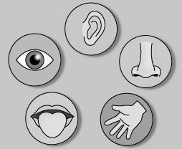
Somethings I’ve:
Seen:
Smelled:
Tasted:
Touched:

Something I noticed/ learned today…

Something that was hard about today…

The highlight of my day…

My prayer for today…

Day One Journaling

Day Two

Snapshot
Today’s mood:
Heard:

Somethings I’ve:
Seen:
Smelled:
Tasted:
Touched:

Something I noticed/ learned today…

Something that was hard about today…

The highlight of my day …

My prayer for today…

Day Two Journaling

Day Three

Snapshot
Today’s mood:
Heard:

Somethings I’ve:
Seen:
Smelled:
Tasted:
Touched:

Something I noticed/ learned today…

Something that was hard about today…

The highlight of my day …

My prayer for today…

Day Three Journaling

Day Four

Snapshot
Today’s mood:
Heard:

Somethings I’ve:
Seen:
Smelled:
Tasted:
Touched:

Something I noticed/ learned today…

Something that was hard about today…

The highlight of my day …

My prayer for today…

Day Four Journaling

Day Five

Snapshot
Today’s mood:
Heard:

Somethings I’ve:
Seen:
Smelled:
Tasted:
Touched:

Something I noticed/ learned today…

Something that was hard about today…

The highlight of my day …

My prayer for today…

Day Five Journaling

Day Six

Snapshot
Today’s mood:
Heard:

Somethings I’ve:
Seen:
Smelled:
Tasted:
Touched:

Something I noticed/ learned today…

Something that was hard about today…

The highlight of my day …

My prayer for today…

Day Six Journaling

Day Seven

Snapshot
Today’s mood:
Heard:

Somethings I’ve:
Seen:
Smelled:
Tasted:
Touched:

Something I noticed/ learned today…

Something that was hard about today…

The highlight of my day …

My prayer for today…

Day Seven Journaling

Day Eight

Snapshot
Today’s mood:
Heard:

Somethings I’ve:
Seen:
Smelled:
Tasted:
Touched:

Something I noticed/ learned today…

Something that was hard about today…

The highlight of my day …

My prayer for today…

Day Eight Journaling

Day Nine

Snapshot
Today’s mood:
Heard:

Somethings I’ve:
Seen:
Smelled:
Tasted:
Touched:

Something I noticed/ learned today…

Something that was hard about today…

The highlight of my day …

My prayer for today…

Day Nine Journaling

Day Ten

Snapshot
Today’s mood:
Heard:

Somethings I’ve:
Seen:
Smelled:
Tasted:
Touched:

Something I noticed/ learned today…

Something that was hard about today…

The highlight of my day …

My prayer for today…

Day Ten Journaling

Lectio Divina Shared in a small group
(An ancient form of seeking to hear God speak to us through the Scriptures is attributed to Saint Benedict (c. 480 – c.543). The basic form has been adapted for use by small groups.)
Choose who will read the text, either the leader or two- three different readers.
Remind people not to use ‘their own words’ in the sharing time, rather only repeating the words and phrases of scripture

- The FIRST reader reads aloud the passage of scripture slowly and prayerfully.

- Silence for 1-2 minutes. We ask ourselves, has a particular word or phrase captured me?” Allow that word or phrase to unhurriedly echo silently within.
- The first reader now speaks aloud the word or phrase which stood out to her/him.
- Sharing aloud: a word or phrase in the text that resonates with you.

- SECOND reading of the same passage

- Silence for 2-3 minutes. Rest in the scene and stay with a particular word or phrase.
- The second reader now speaks aloud the word or phrase from the text which resonates with him or her (the same word as previously or a new one).
- Sharing aloud: a word or phrase from the text that resonates with you.

- Let the group put away their texts and listen to a THIRD slow and prayerful reading.

- Silence for 2-3 minutes.
- The third reader speaks aloud their word or phrase and follows it with a mini-prayer, making use of the word or the words in the phrase.
- Share aloud of your experience listening to and praying the text. Was there something that spoke to you in a particular way? Did the text connect with some aspect of your life?

Five Symbols
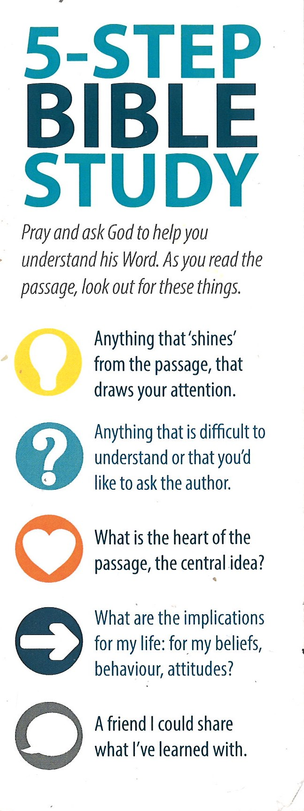

Debrief Notes

Three adjectives that describe this whole ministry exchange for me:
(preparation as well as during)

My overall highlight of the trip:

My overall lowlight of the trip:

The most influential person for me? why?
(this could be someone from your preparation time, someone from the team, or someone from Fiji)

How has this trip changed me?

Fiji Debrief Notes In the Village
Ask “God, in light of all that you did and showed me on the trip, what do you want me to remember as I reengage in my normal life?”
Be patient, listen to his voice, write down whatever comes to mind in the spaces below.
Things I want to remember
About Fiji:

About myself:

About God:

About being a leader and disciple:

Main points to share with others:

DEBRIEF: Preparing for Re-entry

This section covers the debrief for every team to have together while ‘in-country’ before departing for NZ. We recommend that at least two of these studies are done in the village and in Nadi at least part of a day is dedicated to this at the end of your time.

Debriefing overview
This debrief time is broken up into three parts:
- Here (Host Country Location)
- Here to There (What I have learned and am ‘taking back to NZ’)
- There (Looking ahead to NZ)
- Post-it Notes/ Paper

Debrief Session 1: HERE (In the village)
Session Aims / Main Learning:
- To help each person summarise their journey, the highs and lows, and how they have seen God at work.
- To help each person to express their ‘feelings’ and the ‘needs’ in this part of the journey.
- To help each person begin thinking about the transition home.

1. Post-it notes group reflections
You will get 3 post it notes. On each post it note write an adjective that reflects your time in Fiji.
- What has been your overall highlight of the trip?
__________________________________________________________________________________________
- What has been your overall lowlight of the trip?
__________________________________________________________________________________________
- Who has been the most influential person for you? And why? (this could be someone from your preparation time, someone from the team, or someone from Fiji)
__________________________________________________________________________________________
Spend some time sharing answers with the group

2. Self-reflection
Individually spend some time reflecting on the debrief questions - keeping in mind their expectations written on prep weekend before the trip.
Expectations vs reality
- What were your biggest fears or struggles going into the trip?
__________________________________________________________________________________________
__________________________________________________________________________________________

- What actually happened in these areas?
__________________________________________________________________________________________
__________________________________________________________________________________________

- What were your biggest hopes or desires for how God would work on the trip?
__________________________________________________________________________________________
__________________________________________________________________________________________
- What actually happened in these areas?
__________________________________________________________________________________________
__________________________________________________________________________________________

What did you learn about yourself?
- What was the most significant time when you had to ‘step out in faith’ to do something on the trip?
__________________________________________________________________________________________
__________________________________________________________________________________________

- What were you feeling before you did it?
__________________________________________________________________________________________
__________________________________________________________________________________________

- How did God meet you?
__________________________________________________________________________________________
__________________________________________________________________________________________

- What happened as a result?
__________________________________________________________________________________________
__________________________________________________________________________________________

Think of a time when you saw God specifically use you on the trip. It could have been by helping or encouraging a teammate, loving one of the people you came to serve, or giving you the solution to a difficult problem or situation…
- What happened?
__________________________________________________________________________________________
__________________________________________________________________________________________

- What was it like to experience God using you in this way?
__________________________________________________________________________________________
__________________________________________________________________________________________

3. Reflection and sharing: Feelings and needs cards
Look at the Feelings & Needs cards.
Choose one feeling card that describes ‘How they are feeling about leaving Fiji and one need card that describes ‘What they need from God or the group as they prepare to leave’.
Share together and pray for each other.

Debrief Session 2: HERE to THERE
Session Aims / Main Learning:
- To go deeper in reflecting on their time and discern what they have learnt and what God might be saying to them/ inviting them into as a result of this trip (beginning thoughts only)
- To help the team understand how difficult it can be to share their experiences with people at home and to have realistic expectations of themselves/others.
- To prepare the team with different ways of sharing their experiences with others..

Reflection individually: What have I learnt?
Individually spend some time reflecting on the debrief questions in their Journals.
While in Fiji, what have I learnt about:
- Fiji?
- Myself?
- God?
- Being a leader and disciple?
Come back together and share answers with the group.

Preparing to share my experiences
The most common question short-termers hear upon return is ‘How was your trip?’ Some people ask this question as a formality of greeting, others really want to know. Anticipating this question, and that people have different levels of interest can help you make friends with the question, rather than despise it!
Spend some time reflecting on what experiences you will want to share with others, using the following questions in your Journals.
- Highlights
- Lowlights
- Something I never want to forget
- How this GO Team has changed me
- Main points I want to share with others.

Sharing my story
In 15 Seconds (The Sound-Bite Approach)
Quick response/Not much interest

In 1 minute (The Commercial Approach)
Inviting them into a longer conversation or event to hear more
Use stories

In 5 minutes (The Interested Conversation)
Keep in mind there is dialogue

In 20 minutes (The Invited Approach)
Talk or presentation at Church or Youth Group—stories, what God taught you, what God did. Show pictures etc.

Get in pairs and practice ‘The Sound Bite Approach’ and ‘The Commercial Approach’ with each other.

Debrief Session 3: THERE
Session Aims
- To name the fears and hesitations about returning to NZ, what they might love, what they might struggle with in NZ culture now.
Here are some of the challenges that you may face:
- Consumerism of NZ, particularly at Christmas (if applicable to time of year for team)
- Individualistic Culture of NZ
- Not being able to really feel like anyone understands what happened in overseas
- Loss of togetherness with the Team – can be lonely.
- Spiritually Tough: Not having team devotions, that team push to really go deep with God – can feel ‘distance’
- Being really tired after a big experience.
- Adjusting to the climate and food (and even clothing) of NZ again.
There is no real way to avoid these things, but being aware of what some of the challenges are is really important for knowing how to handle them.

Reflection and planning: Next steps for me
How can I be pro-active about transitioning home? (Consider time for rest, family and friends, reading, journal keeping, school, work commitments etc).
Spend some time writing up a plan of some next steps that will help you adjust to NZ, not forget about Fiji, and to share well with others. Using the following outline:
- In the first three days I am home I want to make sure I… (e.g. check emails/facebook, laundry, sleep, see family etc)
__________________________________________________________________________________________
__________________________________________________________________________________________

- In the first full week I am home I want to make sure I… (e.g. send a thank you letter to leader or host, share my story with close friends, sort photos etc)
__________________________________________________________________________________________
__________________________________________________________________________________________

- In the first month that I am home I want to make sure I… (e.g. send thank you letters to my support team, share my story with my youth group or church, talk to my mentor and/or youth pastor about the trip etc)
__________________________________________________________________________________________
__________________________________________________________________________________________
__________________________________________________________________________________________
__________________________________________________________________________________________

- In the first three months that I am home I want to make sure I… (e.g. join the church missions group, begin learning the guitar, start serving in a new ministry at church etc).
__________________________________________________________________________________________
__________________________________________________________________________________________
__________________________________________________________________________________________
__________________________________________________________________________________________

Activity: Write a letter to themselves
As a final reflection on all the things that they’ve discussed in Debrief, ask each person to write a letter to themselves which they will receive in the future. The purpose of the letter is to write down what has been the most significant things for them, write down things that encourage them, and even some goals they’d like to keep to.
Ensure they write their name and postal address clearly on the envelopes!
Team Leader holds onto this and sends it to them in 6 months time.

Keeping the Flame Alive

Read and reflect together:
The “high” is common…as is the return to normalcy that all too often occurs. The euphoric excitement that permeates our minds as we experience being “on fire for God” so often dissipates when we return to our normal schedules, with our normal friends, and our normal habits. How can we fight this return to routine?
Below are some semi-simple ideas we think will help you integrate more effectively into the church body and to inspire you to find the next steps in God’s mission for you.

Tell a Story
Report back to the church: Share stories of how God is working in Fiji, in you, and how this experience can be incorporated into the church body.

Host a Fiji night at Youth Group
Coordinate with your Youth Leaders to host a Fiji night with the Youth Group where you could make food, dress up, and share stories about your time in Fiji. Invite others from the team to come help you do it if you can so you have more people.

Focus on People
Find a photo of someone important in Fiji, or a photo that reminds you of an important time. Put the pictures somewhere you can see them. Write explanation of who the photo is of, what makes that person special, and how that person has impacted you.

Volunteering at Church
Help out with a church ministry. Volunteer your services for a Sunday during service(s) to show your involvement and dedication to the home church family.

Facebook Friday
Consider staying in touch regularly with people you met in Fiji via Facebook. You might want to share what God has been doing in your life, and offer words of encouragement and prayer.

Fast and Pray
Even though you’ve been back for a while, in Fiji, life is still going on as we left it. Consider setting aside a lunch time one week to fast and pray for the ministry work to continue in your village.

Join the Church Missions Team
Consider joining the missions team at church, maybe for a one off, or ongoing involvement. This might include asking what kind of role you could have, how you could keep learning about mission the church is involved in, keeping the church informed about mission etc, etc.

BACK HOME: Re-vision for Mission
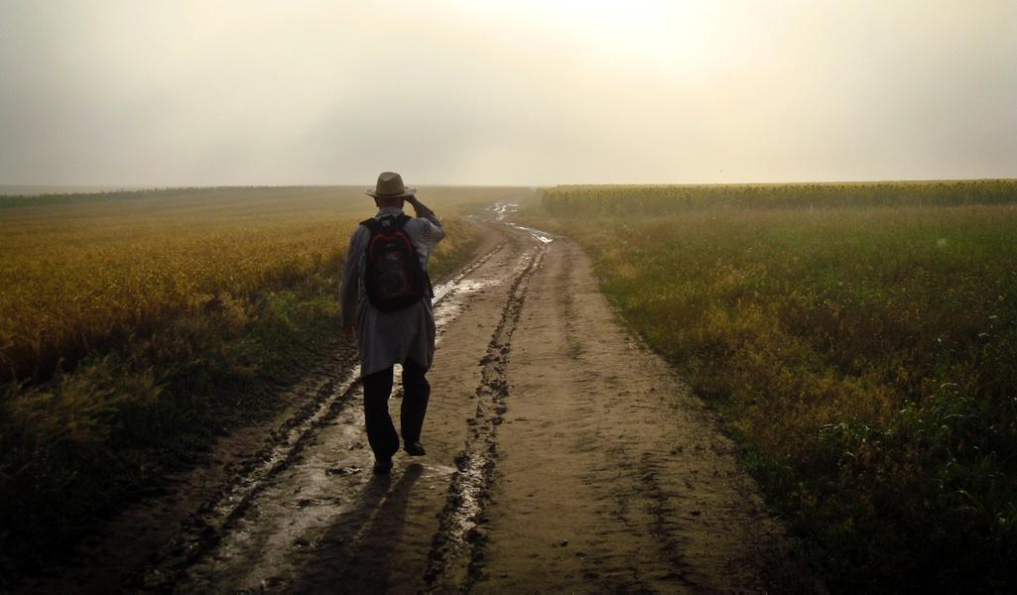

God’s walk with me since the GO Team
Session Aims / Main Learning:
- Recognising that the GO Trip wasn’t the point. We are not over the finish line; what happens now is just as important.
- Reflect as a team on the GO Team, and name some of the challenges and joys of sharing about it with family/friends.
- Reviewing and reflecting on some aspects of God’s calling in individuals lives.

Opening reflection:
What does God have to say to me?
Statement: “God loves me the same amount today as He did when I was feeling my most ‘missiony and serving’ whilst overseas.” True or False?
Invite a everyone to spend 5 minutes writing about this statement and what they feel for themselves. (If group is up for it, invite some people to share).
_______________________________________________________________________________________________
_______________________________________________________________________________________________
_______________________________________________________________________________________________
_______________________________________________________________________________________________

Returning role play:
(Fiji specific)
Leader pretends to be ‘friends’ ‘family’ who ‘meet’ a team member, and start asking them about their GO Team:
Each ‘friend’ has a different idea about Fiji (as directed on the cards below).
Person One: Mission is only about ‘converts’: Act really enthusiastic about Fiji, but only about the mission work related to how many ‘converts’ they made in Fiji.
Person Two: Cynical about Fiji: You think Fiji was an excuse for a holiday, you are cynical about Fiji, ask them questions but keep on referring to how many beaches they visited and say ‘GO Team’ with hands up signalling inverted comas.
Person Three: Doesn’t Care: You don’t care about Fiji, and are uninterested. Keep on changing the topic to talk about anything else, the weather, sport, your Christmas gifts, or say nothing at all!
Person Four: Really gets it, is interested: You care about the person and want to hear their stories. Asks what they learnt, how did they grow.
Person Five: Life-changing experience? You want to know how Fiji has changed this person’s life, how are they different. What are they doing now they didn’t do before etc…

Main point:
Remind the team that they’ve been reflecting on Fiji whether we know it or not. Our friends and family have impacted how we’ve felt about it. But, how has it changed and impacted us as disciples of Jesus?
The fact is: Fiji is not the goal. Fiji, can be life-changing, significant events on their own aren’t life-changing, it’s how you learn from them, and what goals you seek to reach because of them that make the difference.

Individual reflections activity:
Since coming back to NZ the best things have been:
_________________________________________________________________________________________________
_________________________________________________________________________________________________
_________________________________________________________________________________________________
_________________________________________________________________________________________________
Since coming back to NZ the worst things have been:
_________________________________________________________________________________________________
_________________________________________________________________________________________________
_________________________________________________________________________________________________
_________________________________________________________________________________________________
I’ve struggled with:
_________________________________________________________________________________________________
_________________________________________________________________________________________________
_________________________________________________________________________________________________
_________________________________________________________________________________________________
I’m excited by:
_________________________________________________________________________________________________
_________________________________________________________________________________________________
_________________________________________________________________________________________________
_________________________________________________________________________________________________
My family feels like…
_________________________________________________________________________________________________
_________________________________________________________________________________________________
_________________________________________________________________________________________________
_________________________________________________________________________________________________
My church feels like…
_________________________________________________________________________________________________
_________________________________________________________________________________________________
_________________________________________________________________________________________________
_________________________________________________________________________________________________
My youth group feels like…
_________________________________________________________________________________________________
_________________________________________________________________________________________________
_________________________________________________________________________________________________
_________________________________________________________________________________________________
My school feels like…
_________________________________________________________________________________________________
_________________________________________________________________________________________________
_________________________________________________________________________________________________
_________________________________________________________________________________________________

God’s Call: How is God inviting me to grow?
Session Aims / Main Learning:
- Reviewing and reflecting on some aspects of God’s calling in individuals lives.
- Evaluating areas of challenge and growth in my life
- Looking at following aspects of a young person’s life
  - How do I use my time?
  - What people are influencing me?
  - How am I using my resources?
  - How am I learning?

Opening reflection: How do I want to be remembered at the end of my life?
Imagine it is your funeral and friends and family get up to speak about you - what kind of things would you like them to say, as they talk about your life, what would you have hoped to have achieved?
_________________________________________________________________________________________________
_________________________________________________________________________________________________
_________________________________________________________________________________________________
_________________________________________________________________________________________________
_________________________________________________________________________________________________
_________________________________________________________________________________________________
_________________________________________________________________________________________________
_________________________________________________________________________________________________
_________________________________________________________________________________________________
_________________________________________________________________________________________________
_________________________________________________________________________________________________
_________________________________________________________________________________________________
_________________________________________________________________________________________________
_________________________________________________________________________________________________
_________________________________________________________________________________________________
_________________________________________________________________________________________________
_________________________________________________________________________________________________
_________________________________________________________________________________________________
_________________________________________________________________________________________________
_________________________________________________________________________________________________

Big picture: What is God’s calling for me?
Explanation: As a young person, you are at an age and stage, where wondering and figuring out our future direction is important. (we’ve already made choices for schooling cos of it, and there might already be words from God that you feel speak to you about a calling/direction. This isn’t about contradicting it, this is about confirming what God is saying. There is no right or wrong answers. But we are just going to pause for a few minutes and consider the big picture: What have there been any experiences during the GO Team preparation, trip, and returning that have been significant in terms of understanding more about your gifts and calling?
This will be different for each of us. Sometimes it’s like an experience where you feel ‘really alive’ really yourself. Or perhaps something that set a fire in you like you haven’t had before. It might be that there was a time you experienced something you loved doing that you didn’t know you could do before. There’s no formula for it. This is just an activity to notice what you notice.
(Suggested questions for reflection: use some/all)
- What did God teach you about yourself (strengths/ weaknesses?) while on the GO Team?
- What part of the GO trip made me feel ‘really alive’?
- What ministry gifts have you grown in since before the GO Team?
- Is there an area of deep injustice that has God stirred up in you?
- What people/group that is on the margins of society/culture do you care about?
- If time/money/location wasn’t a barrier what is the dream of how you want to live your life?

Evaluating my time:
C H O O S E W H A T T O L E A V E O U T
HEDONIC TREADMILL
Definition: A theory proposing that people stay at about the same level of happiness regardless of what happens to them.
More simply put, an example of the Hedonic Treadmill is when we pray, receive amazing blessing from God, yet still feel the same as before. We realize the thing we predicated our happiness has come to pass but our happiness hasn’t changed.
Imagine this playing out when life gets better, but we still live in a rut, draw the same negative conclusions, and sabotage our success. The underlying theme here; Regardless of income, good health, and our relationships, we want more. Out happiness doesn’t seem to improve as our possessions, position and power do.
Most people have a few things that they do that cause the majority of their pain (like binge eating, staying up late watching TV/ Netflix or not having a budget). Instead of living in this cycle year after year, you can save this destructive tendency by just realizing what they are. A great quote from Tim Ferris from the New York Times best seller author is,
“What 20% activity are causing 80% of you negative emotions.”

IDENTIFIER
What is the single greatest time waster in your life?
_________________________________________________________________________________________________
_________________________________________________________________________________________________
What is the next biggest time waster in your life?
_________________________________________________________________________________________________
_________________________________________________________________________________________________
Good leaders have to do lists in their lives. Great leaders have ‘stop doing’ lists. What we stop doing can be just as important as what we start to do. A stop doing list always heightens your focus with your passion purpose and calling. What is costing your time, energy and money that doesn’t fit?
List three things that you should stop doing?
_________________________________________________________________________________________________
_________________________________________________________________________________________________
_________________________________________________________________________________________________
_________________________________________________________________________________________________
_________________________________________________________________________________________________
THOUGHT STARTERS Drinking caffeine, watching Netflix, eating out, working during family time, trying to please other people, hanging out with………….., eating late, spending time on Facebook, being fearful of……, avoiding………..

Evaluating my influences:
W H A T ‘ S S H A P I N G Y O U ?
Associations (definition): A link between people or an organization for a joint purpose.
Maybe you have heard this quote from Charlie Tremendous Jones before, “You are the same person you are today in five years’ time, except for two things: The books you read and the company you keep.
Our associations unconsciously guide our future. Here, take a few moments to intentionally reshape your future in the direction you want. Ponder, dream, imagine and clarify.
_________________________________________________________________________________________________
_________________________________________________________________________________________________
_________________________________________________________________________________________________
_________________________________________________________________________________________________
_________________________________________________________________________________________________
WITH YOUR GOALS IN MIND…
As the two greatest determinations of the future you is what you spend your time thinking about (reading) and those who you hang out with are there people you need to choose to spend more time with and some that you need to spend less with.
_________________________________________________________________________________________________
_________________________________________________________________________________________________
_________________________________________________________________________________________________
_________________________________________________________________________________________________
_________________________________________________________________________________________________
BOOKS
How can you fit more reading into your life? How can you find great books as well as the bible? _________________________________________________________________________________________________
_________________________________________________________________________________________________
_________________________________________________________________________________________________
MENTORS
Consider committing to a mentor, coach, trainer or a spiritual guide to reinforce your growth. Mentors are people who you can chat through life’s issues and they can help you reflect on what’s going on around you, add their wisdom and hold you accountable for the changes you want to make. Is there anyone you can think of who might be a good mentor, coach etc?
_________________________________________________________________________________________________
_________________________________________________________________________________________________
_________________________________________________________________________________________________

Summarising your evaluations/reflections and God’s call:
My biggest dreams are:
_________________________________________________________________________________________________
_________________________________________________________________________________________________
_________________________________________________________________________________________________
_________________________________________________________________________________________________
_________________________________________________________________________________________________

My biggest challenges right now are:
_________________________________________________________________________________________________
_________________________________________________________________________________________________
_________________________________________________________________________________________________
_________________________________________________________________________________________________
_________________________________________________________________________________________________

What are some practical next steps for each in working towards your goals
(think SMART goals! Specific, Measurable, Attainable, Realistic, and Timely.)
_________________________________________________________________________________________________
_________________________________________________________________________________________________
_________________________________________________________________________________________________
_________________________________________________________________________________________________
_________________________________________________________________________________________________

Share in groups if people free comfortable.

God’s Community: Keeping us accountable and growing in God’s mission

Session: Being a disciple patterned after Jesus’ way.
Session Aims / Main Learning:
- Recognising how to be a disciple after Jesus’ Way.
- Evaluating the ‘rhythm of life’ during the GO Team and how to learn from that.
- Teach 3DM’s tool: UP-IN-OUT as a model for balancing life.
- Plan and dream as a team how to keep community life going and how to invest in the ‘OUT’ as a group.

Opening activity: Team brainstorm
How did we structure our time on the GO Team? What did you notice? What different activities did we do in relation to God, team, mission/ministry?
Get group feedback and write on whiteboard.
- UP: e.g. Daily devos, journaling, worship, prayer,
- IN: e.g. Team time, investing in each other’s lives, Youth in Dreketi, encouraging the church community.
- OUT: e.g. Ministry opportunities, market place, visiting Hindu community…
‘This is what the LORD requires of you, to Act Justly, Love Mercy, and Walk Humbly with our God. Micah 6:8


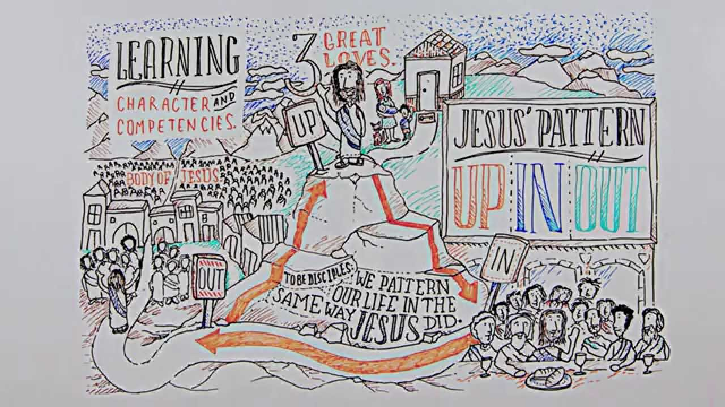

Team reflections:
- What can we learn from this model or UP/IN/OUT and how can we balance UP/IN/OUT in our lives here in NZ as disciples of Jesus?
__________________________________________________________________________________________
- Is there anything about life in Fiji that we practiced that you want to implement in NZ as a group?
__________________________________________________________________________________________

Individual Reflections: think about this individually for your own life balance:

UP Questions:
- How’s your time with Jesus going?
__________________________________________________________________________________________
- Are you spending time reading God’s Word regularly?
__________________________________________________________________________________________
- Do you feel like you worship God?
__________________________________________________________________________________________
- Are you being led by the Holy Spirit?
__________________________________________________________________________________________
- Do you have any areas of brokenness/sin to confess?
__________________________________________________________________________________________
- Are you obedient to God?
__________________________________________________________________________________________
- Are you trusting God?
__________________________________________________________________________________________
- Are you experiencing joy in Him?
__________________________________________________________________________________________

IN Questions:
- Are you feeling encouraged and challenged by your youth/church/community?
__________________________________________________________________________________________
- Are you a part of a community that encourages you to live the balance of UP/IN/OUT?
__________________________________________________________________________________________
- How are you vulnerable with your group?
__________________________________________________________________________________________
- Is there any unresolved conflict between you and others?
__________________________________________________________________________________________
- Do you feel that you belong?
__________________________________________________________________________________________
- Do you contribute to the group?
__________________________________________________________________________________________

OUT Questions:
- Can you share your testimony?
__________________________________________________________________________________________
- Can you share a simple Gospel presentation?
__________________________________________________________________________________________
- Are there issues of social justice that you are engaged in?
__________________________________________________________________________________________

- How are you spending time with the ‘Last, Lost, and Least’ in society?
__________________________________________________________________________________________
- Do you pray for the issues/people in other parts of the world?
__________________________________________________________________________________________

Takeaways/Next Steps:
What are the next steps in creating this balance and how will you reflect/review this?
_________________________________________________________________________________________________
_________________________________________________________________________________________________
_________________________________________________________________________________________________
_________________________________________________________________________________________________
_________________________________________________________________________________________________
_________________________________________________________________________________________________
_________________________________________________________________________________________________
_________________________________________________________________________________________________

God’s Mission: How can we engage with God’s broken world
Before we left for Fiji we used this info graphic to help us understands God’s big picture to bring about Gods kingdom to restore relationships in individuals, communities and creation.
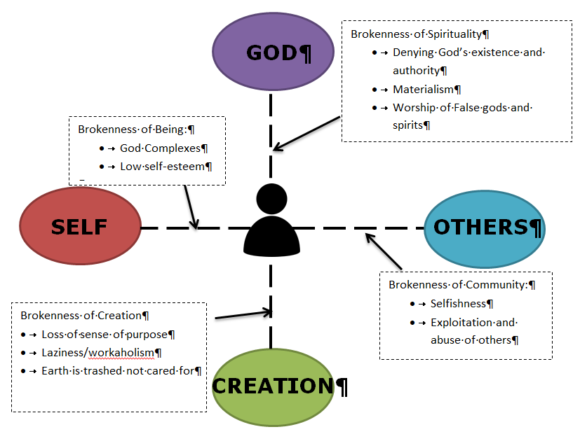
Now that we have been to Fiji how do you understand this?
How might God be inviting us to be on his mission in our youth group?
_________________________________________________________________________________________________
_________________________________________________________________________________________________
_________________________________________________________________________________________________
_________________________________________________________________________________________________
Together in our school?
_________________________________________________________________________________________________
_________________________________________________________________________________________________
_________________________________________________________________________________________________
_________________________________________________________________________________________________
In our community?
_________________________________________________________________________________________________
_________________________________________________________________________________________________
_________________________________________________________________________________________________
_________________________________________________________________________________________________
In the world?
_________________________________________________________________________________________________
_________________________________________________________________________________________________
_________________________________________________________________________________________________
_________________________________________________________________________________________________
What could God be calling us to do together to bring about his restoration?
_________________________________________________________________________________________________
_________________________________________________________________________________________________
_________________________________________________________________________________________________
_________________________________________________________________________________________________

