The Easiest and Most Awesome Lesson Plan Ever
Why do we have the Tribe? What’s our goal? When do we celebrate?

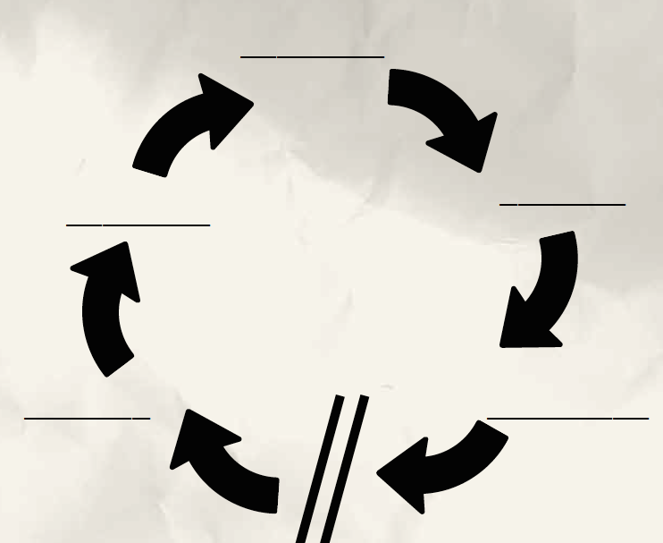

- _________ a) People come dist__________ and disc_________
We need to help them feel_____________________________.
We do it by ______________________________________.

- ___ook:
  - pulling everyone together
  - _____________ the topic
Ideas for _ooks ________________________________________

- ___ook: what does the Bible ____________?
Ideas for _ook_________________________________________

- ___ook: what does the Bible ____________?
Ideas for _ook_________________________________________

- ___ook: what am I going to _________________?
_____________________________________________________
Today’s theme: The Great Commandment - the Golden rule.
Today’s passage: Matthew 22: 34 - 40

